**Robot youpi**

**kinematic diagram and DH parameters**

Last revision : 19/10/24 – DANIEL Olivier

θ4

θ5

θ3

θ2

θ1

x0

z0

y0

z3 | y4

x3 | z4

y3 | x4

z2

x2

y2

z1

x1

y1

X5

Z5

Y5

|  |  |  |  |  |
| --- | --- | --- | --- | --- |
| [Robot youpi's DH Parameters](https://en.wikipedia.org/wiki/Denavit%E2%80%93Hartenberg_parameters) | | | | |
| Joint i | θi (deg) | αi (deg) | ai / ri (cm) | di (cm) |
| 1 | 180 | 90 | 0 | 28 |
| 2 | 90 | 0 | 16.2 | 0 |
| 3 | 0 | 0 | 16.2 | 0 |
| 4 | 90 | 90 | 0 | 0 |
| 5 | 0 | 0 | 0 | 15 |

a1 : 280mm

a2 : 162mm

a3 : 162mm

a4 : 0mm

a5 : 150mm

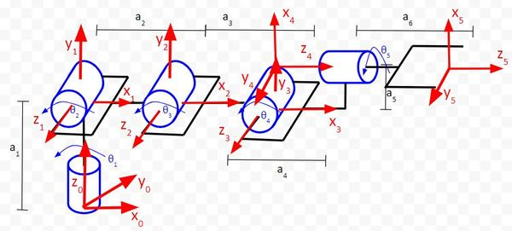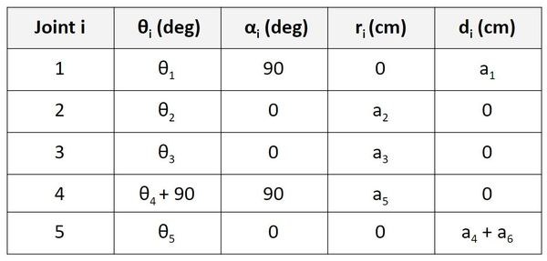

[Online example :](https://automaticaddison.com/the-ultimate-guide-to-inverse-kinematics-for-6dof-robot-arms/)

1)The **z-axis is the axis of rotation** for a revolute joint.

2)The **x-axis must be perpendicular** to both the **current z-axis and the previous z-axis.**

3)The **y-axis is determined** from the x-axis and z-axis by **using the [right-hand coordinate system](https://en.wikipedia.org/wiki/Right-hand_rule" \l "Coordinates)**

(You stick your fingers in the direction of x. Your thumb goes in the direction of z. Your palm faces the direction of y).

4)The **x-axis must intersect the previous z-axis** (rule does not apply to frame 0).

* θ is the **angle from xn-1 to xn around zn-1 (trigonometric sense.)**

* α is the **angle from zn-1 to zn around xn (trigonometric sense.)**

* r (sometimes you’ll see the letter ‘a’ instead of ‘r’) is the **distance between the origin of the n-1 frame and the origin of the n frame along the xn direction.**

* d is the **distance from xn-1 to xn along the zn-1 direction.**

How to :